AXI Streaming Bridge -RX Functional Design Specifications
  - Design and Implementation of CSI Controller IP
  - Version 4.0.1

  - Block Owner
Hana Samy Ahmed
  - Authors
Hana Samy Ahmed

This Page is left Blank Intentionally

Table of Contents
1 Table of Contents 1
2 Revision History 2
3 Overview 3
4 Operation and Description 3
4.1 Digital Interface 3
4.1.1 Parameters Names 3
4.1.2 Ports Names 3
4.2 Functional Description 3
4.3 Block Diagram 3
4.4 Timing Diagram 3
4.5 Verification Requirements 3

Revision History
Version | Date | Author(s) | Revision Notes | Owner Approval
1 | 9-2-2026 | Hana Samy

Overview
The AXI Streaming Bridge acts as an interface adapter between the custom internal video pipeline (coming from the Asynchronous FIFO) and the standard system interconnect (AXI4-Stream).
Its primary function is width adaptation and protocol compliance. It takes 24-bit pixel data (RGB888), pads it to 32 bits (standard word alignment), and manages the AXI VALID/READY handshake to ensure seamless data transfer to the downstream system (e.g., DMA or Frame Buffer).

Operation and Description

Digital Interface

Parameters Names
Parameter Name | Default | Description
P_PIX_WIDTH | 24 | Must match FIFO Output Width.
P_AXI_WIDTH | 32 | Width of the Master AXI Bus.

Ports Names
Port Name | Port Width | Port Type | Description
System
i_aclk | 1 | In | AXI System Clock.
i_aresetn | 1 | In | AXI System Reset.
Input (From FIFO)
i_pix_data | 24 | In | Pixel Data.
i_pix_last | 1 | In | End of Line Flag.
i_pix_user | 1 | In | Start of Frame Flag.
i_pix_valid | 1 | In | Pixel Valid.
o_pix_ready | 1 | Out | Backpressure. Connects to FIFO i_r_ready.
AXI Master Output
m_axis_tdata | 32 | Out | AXI Data Bus.
m_axis_tkeep | 8 | Out | Byte Keep (valid bytes in word).
m_axis_tlast | 1 | Out | AXI Packet Boundary (EOL).
m_axis_tuser | 1 | Out | AXI User Signal (SOF).
m_axis_tvalid | 1 | Out | Master Valid.
m_axis_tready | 1 | In | Slave Ready (Backpressure from System).

Functional Description
Detailed description about the block functionality should be written here
The block operates as a transparent bridge with combinatorial logic for data formatting and a simple pass-through for flow control.
- Data Width Expansion (Padding):
  - The input i_pix_data is 24 bits wide (3 Bytes).
  - The output m_axis_tdata is 32 bits wide (4 Bytes).
  - Logic: m_axis_tdata[23:0] maps directly to i_pix_data.
  - Padding: m_axis_tdata[31:24] is explicitly driven to 0x00 (Zero Padding).
- Handshake Management (Flow Control):
  - Forward Path: m_axis_tvalid connects directly to i_pix_valid.
  - Backward Path: o_pix_ready connects directly to m_axis_tready.
  - Note: The bridge does not buffer data; if the AXI slave asserts backpressure (m_axis_tready = 0), the bridge immediately asserts backpressure to the FIFO (o_pix_ready = 0).
- Sideband Signals:
  - m_axis_tlast follows i_pix_last (marking the end of a video line).
  - m_axis_tuser follows i_pix_user (marking the start of a video frame).
  - m_axis_tkeep: Driven to a constant value to indicate valid byte lanes.
    - For 24-bit data in a 32-bit container, this is typically set to 0x0F (indicating the whole 32-bit word is a valid transfer, with the upper byte being valid "padding") or 0x07 (indicating only the lower 3 bytes are data).
    - Default Implementation: 8'h0F (Assuming standard 32-bit word alignment requirements).

Block Diagram
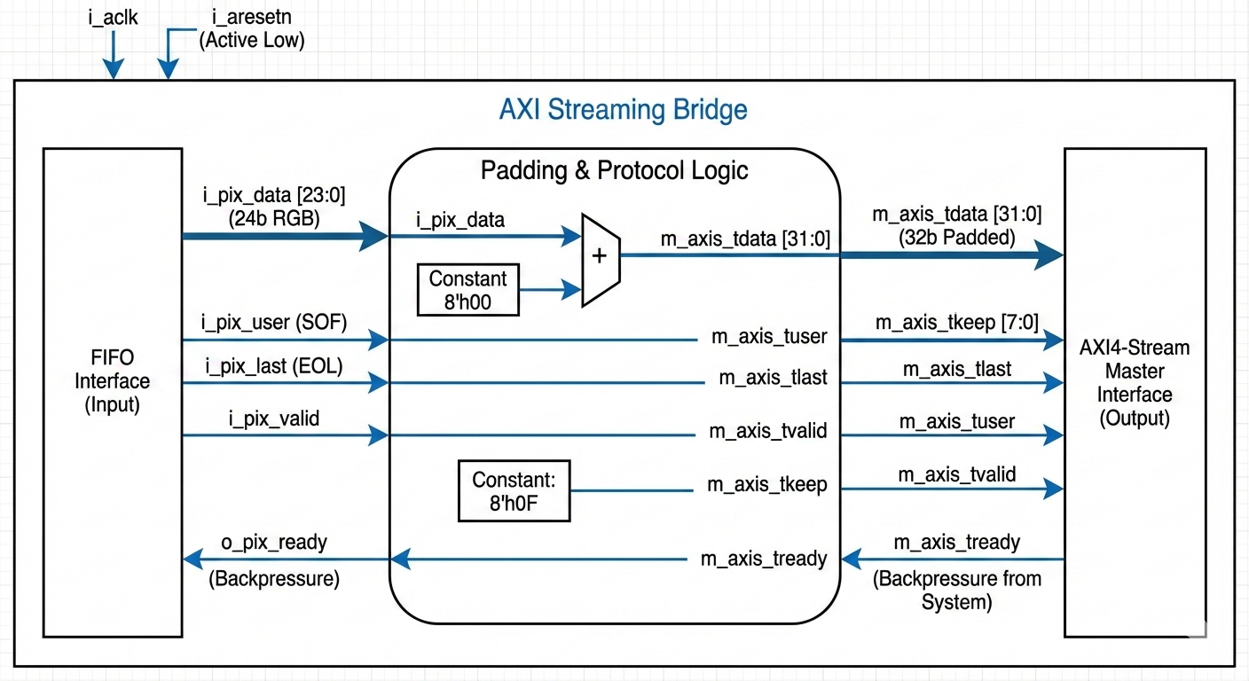

Timing Diagram
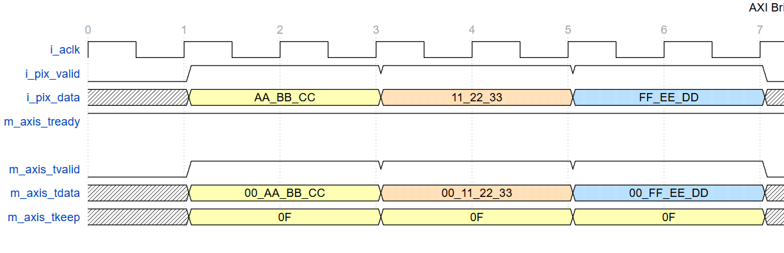

Verification Requirements
- Data Integrity: Verify that m_axis_tdata[23:0] exactly matches i_pix_data and that m_axis_tdata[31:24] is always 0x00.
- Handshake Compliance:
- Verify o_pix_ready goes low immediately when m_axis_tready goes low.
- Verify m_axis_tvalid does not assert if i_pix_valid is low.
- Boundary Check: Verify m_axis_tlast asserts exactly on the last pixel of the line and m_axis_tuser asserts exactly on the first pixel of the frame.
- Reset Behavior: Ensure o_pix_ready is low (busy) or handles the reset state correctly when i_aresetn is asserted.

